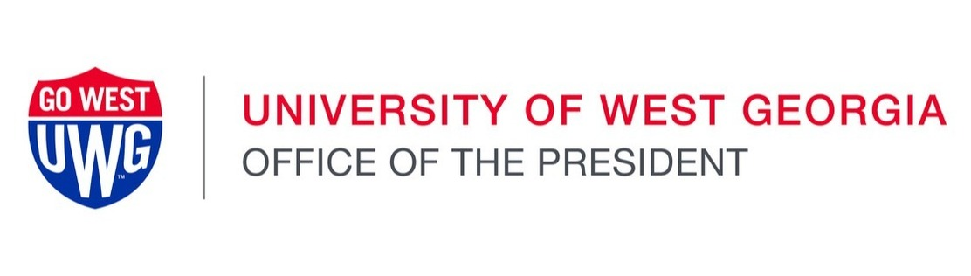

|  |  |
| --- | --- |
| |  | | --- | | Colleagues,  Since I began as interim president here at the University of West Georgia in August, I have been energized by who we are, and who we can become. The day I took on this role, I put forward one key goal: helping more students cross the finish line to graduation. I keep hearing about how you are embracing this goal in everything that you do. Our faculty members are working hard to help students appreciate how their studies will lead to fulfilling careers, motivating them to not give up but persist toward their degree. Our staff members are supporting our students with solutions that are blended with empathy and encouragement, making sure that all links on a student’s path to graduation hold strong. All of you are supporting enriching campus experiences that make students feel connected with the UWG community, while preparing them for exciting careers that lie ahead.  Even in my short period at UWG, so much has been going on. It is hard to pick what to highlight but let me share a few recent events that are elevating the student experience.   * **Division I athletes across our different sports have enlivened our campus.** Winning the Homecoming football game was particularly special, because we were joined by numerous inspiring alums—they represent who UWG students can become. We also saw student teams in action, ranging from the Marching Wolves to our multiple championship-winning cheerleaders, to the student crew that is responsible for sending a live feed to ESPN+. At UWG, D1 is about all the student experiences that go along with sports. * **We celebrated the naming of the Dr. James ‘Earl’ Perry College of Mathematics, Computing, and Sciences.** This naming was backed by generous support from an alum, demonstrating how a single faculty member has the power to inspire. “Earl the Pearl” helped inspire a student who became a highly successful alum, who in turn returned to support our students so that they too become successful alums. Faculty members from this college are already working hard to provide students with an exceptional academic experience, such as through a **$413,000 grant from the U.S. Department of Defense** to support the purchase of a time-resolved emission spectrometer, which can capture minute changes in materials—changes that occur within trillionths of a second. Our undergraduate students will benefit from world-class equipment that is usually reserved for graduate students at the top institutions in the world. * We cut the ribbon on the **newly renovated Humanities building**, providing an updated, vibrant space for learning and collaboration that elevates our students’ academic experiences. * The Richards College of Business has been busy **providing students insights into the macro trends shaping our world**. Recent events ranged from a student group that invited top business leaders to share their wisdom, to a vibrant discussion on economic forecasts that involved the “who’s who” from Georgia businesses and communities. * The annual “A Day to Give West” fundraising campaign raised **$1.67 million** to strengthen our resources so that we can continue to build excellent experiences that set up our students for success.   We will continue to enhance our student experiences, so that students stay connected to UWG and keep moving forward toward graduation. Such experiences also ensure a bright future upon graduation. **UWG graduates earn an additional $1.4 million in their lifetimes** relative to their counterparts who do not complete a bachelor’s degree, and this number is even higher for those who go on to complete graduate degrees. Moreover, **UWG is ranked third in Georgia for social mobility** by U.S. News and World Report, demonstrating that our education is truly elevating students and their families  These achievements are particularly notable because we accomplish them while embracing the core values—integrity, excellence, accountability, and respect—that we share with the other 25 institutions in the University System of Georgia.   This year, as we celebrate Ethics Awareness Week, Nov. 4-10, we are highlighting our ongoing commitment to ethics. See the [UWG Ethics Awareness Week website](https://nam12.safelinks.protection.outlook.com/?url=https%3A%2F%2Ft.e2ma.net%2Fclick%2Fwwnhbg%2Fgwketcye%2F0rarbl&data=05%7C02%7Ctdemilio%40westga.edu%7Ca6ab7eec055b4109e16908dcfa8e71c7%7C8de19331cc30459f84436a4b68734b50%7C0%7C0%7C638660736935925284%7CUnknown%7CTWFpbGZsb3d8eyJWIjoiMC4wLjAwMDAiLCJQIjoiV2luMzIiLCJBTiI6Ik1haWwiLCJXVCI6Mn0%3D%7C0%7C%7C%7C&sdata=BMNR5U83yPZSEhDW%2FGcbkbQImTC8DfBs4FQDAKtag9g%3D&reserved=0) for details on events and programming this week.  **I encourage you to attend two system-wide events next week. USG Chancellor Sonny Perdue’s event on Monday at 10 a.m. (to be streamed on**[**Microsoft Teams**](https://nam12.safelinks.protection.outlook.com/?url=https%3A%2F%2Ft.e2ma.net%2Fclick%2Fwwnhbg%2Fgwketcye%2Fgkbrbl&data=05%7C02%7Ctdemilio%40westga.edu%7Ca6ab7eec055b4109e16908dcfa8e71c7%7C8de19331cc30459f84436a4b68734b50%7C0%7C0%7C638660736935942556%7CUnknown%7CTWFpbGZsb3d8eyJWIjoiMC4wLjAwMDAiLCJQIjoiV2luMzIiLCJBTiI6Ik1haWwiLCJXVCI6Mn0%3D%7C0%7C%7C%7C&sdata=VZoc8q99qXRKBYW0qs%2BqLjI3mAOXQjtvk7lrDB2U9Tk%3D&reserved=0)**) will feature the Honorable Nels S.D. Peterson, Presiding Justice of the Georgia Supreme Court. In addition, the USG Ethics and Compliance Best Practices Panel will be held Friday at 10 a.m. (register via**[**Zoom**](https://nam12.safelinks.protection.outlook.com/?url=https%3A%2F%2Ft.e2ma.net%2Fclick%2Fwwnhbg%2Fgwketcye%2Fwccrbl&data=05%7C02%7Ctdemilio%40westga.edu%7Ca6ab7eec055b4109e16908dcfa8e71c7%7C8de19331cc30459f84436a4b68734b50%7C0%7C0%7C638660736935959984%7CUnknown%7CTWFpbGZsb3d8eyJWIjoiMC4wLjAwMDAiLCJQIjoiV2luMzIiLCJBTiI6Ik1haWwiLCJXVCI6Mn0%3D%7C0%7C%7C%7C&sdata=D%2BZ2A1XhsscONP88iuzhOmrxtAIo4NjA9%2FU96Igdce4%3D&reserved=0)**).**  Thank you for your dedication and passion. You are contributing to the vitality and success of UWG through your daily work and through your commitment to the shared values that unite us. Together, we’re shaping a future that empowers our students and positions the university for even greater success in the future.  Go West and Go Wolves! | |

|  |  |  |  |  |
| --- | --- | --- | --- | --- |
| |  |  |  |  | | --- | --- | --- | --- | | |  |  |  | | --- | --- | --- | | |  |  | | --- | --- | | Signature of Dr. Ashwani Monga   |  | | --- | | Ashwani Monga, Ph.D. *Interim President* **University of West Georgia** | | | | |